FONACIER, John Matthew B.

09/06/2018

CSIT01

Step 1: Create a folder in your computer for the repository

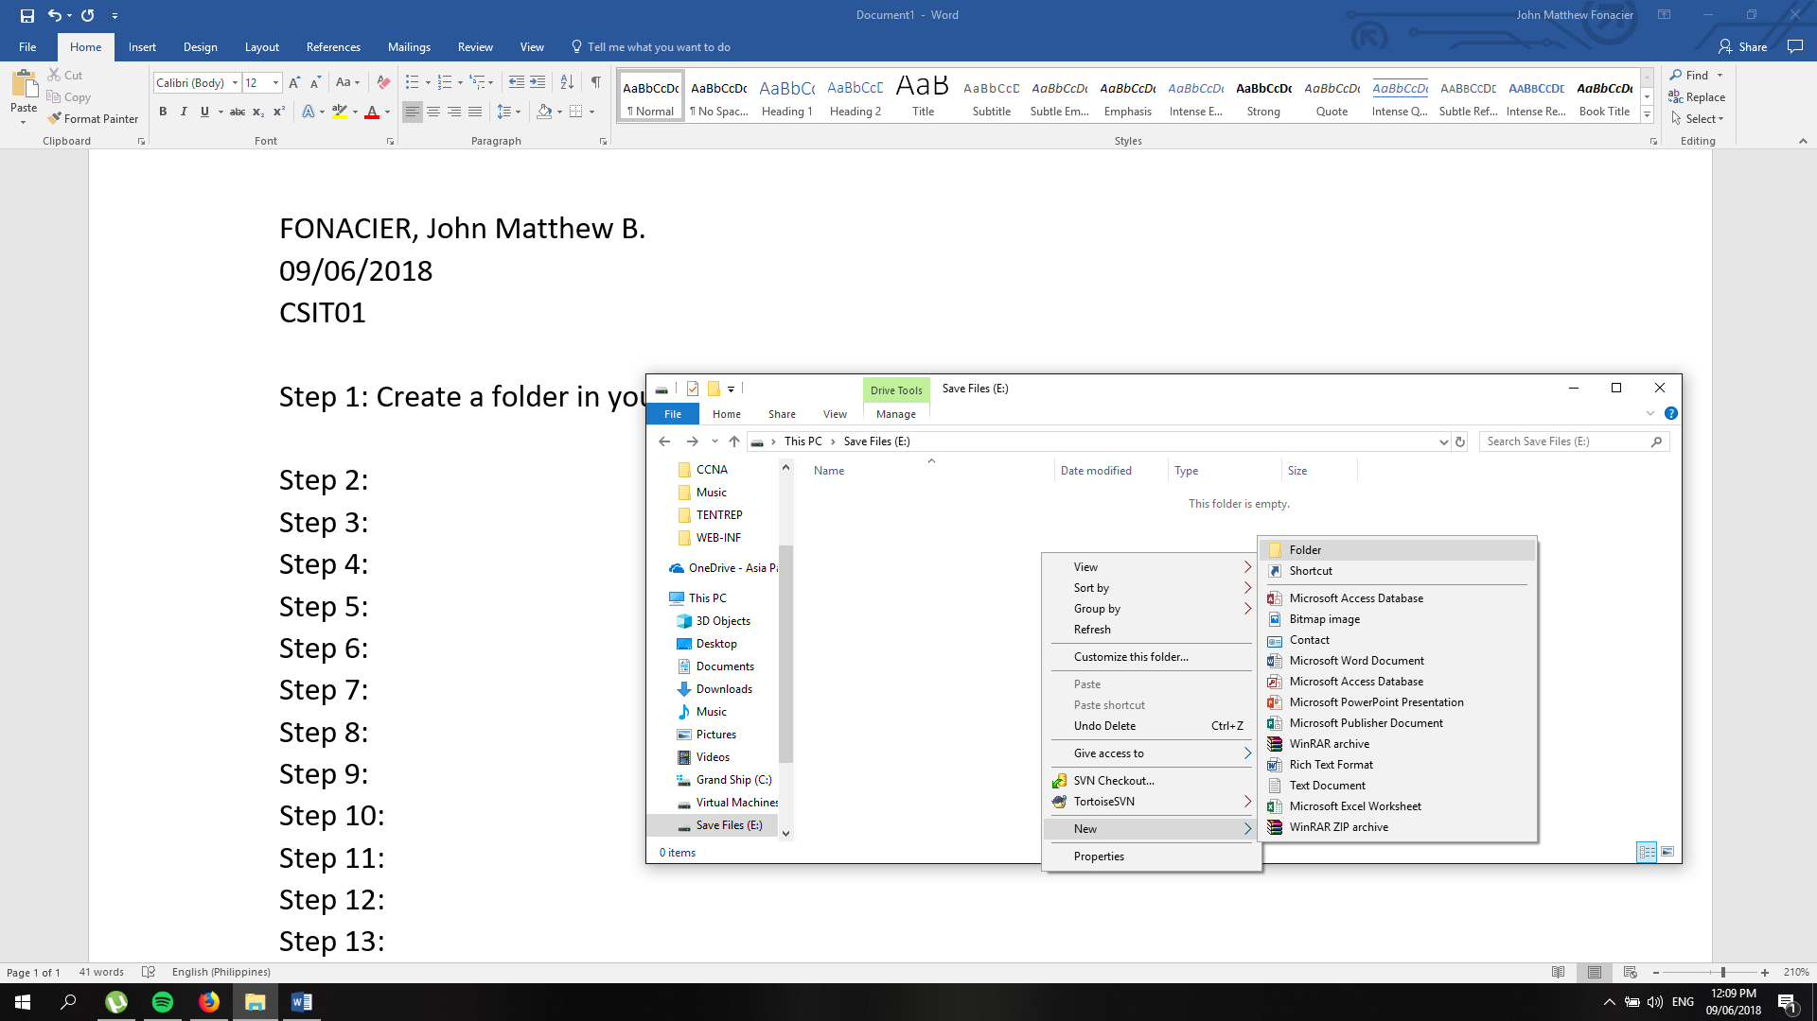

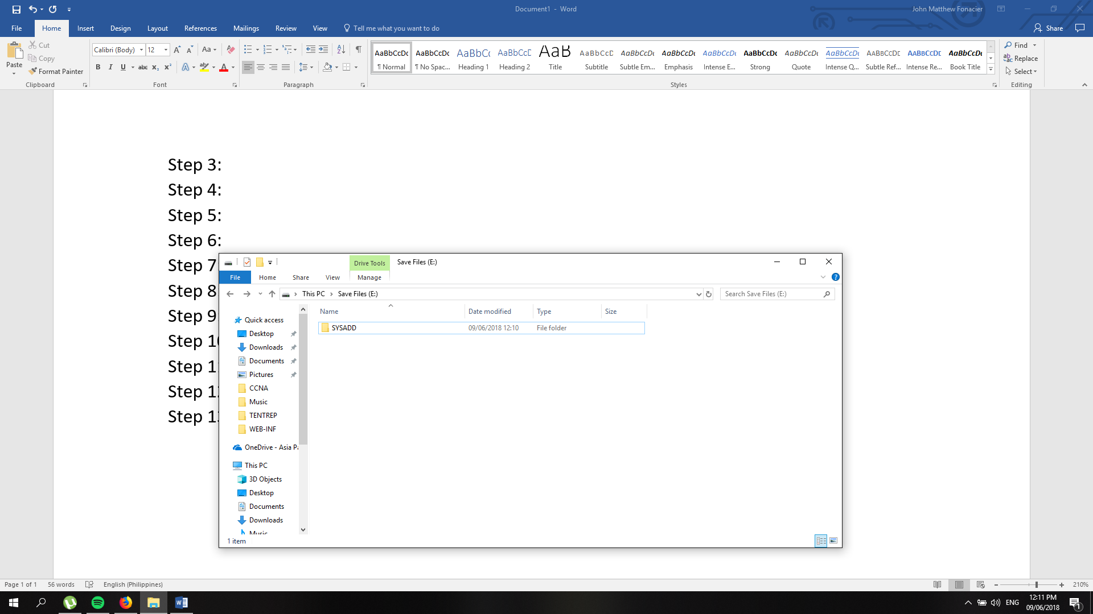Step 2: The name of the folder doesn’t necessarily have to be the same of your repository

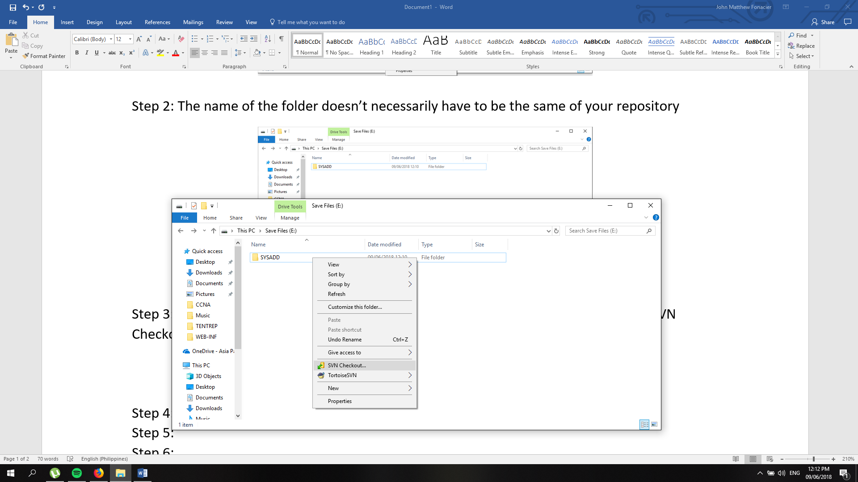Step 3: After downloading Tortoise SVN, right click the folder you created then click “SVN Checkout”

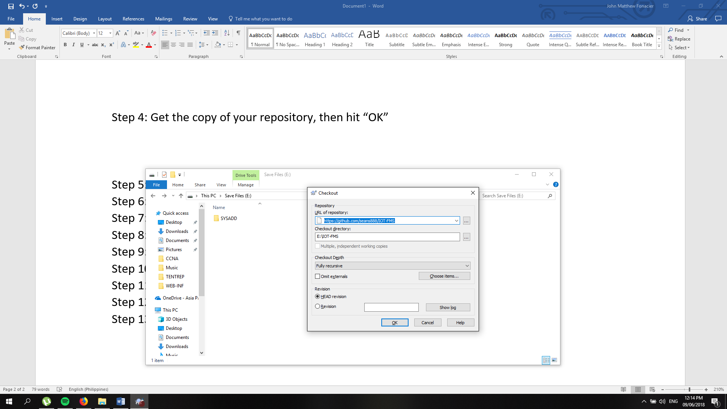Step 4: Get the copy of your repository, then hit “OK” it will synchronize the current contents of that repository to the folder you created

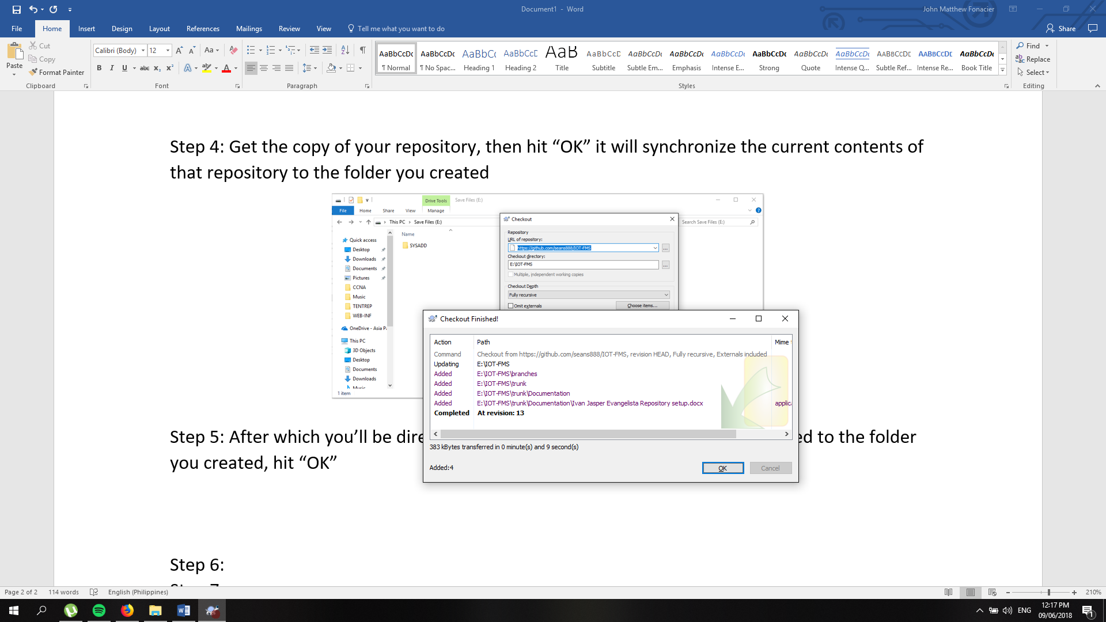Step 5: After which you’ll be directed to another tab, logs of files that were added to the folder you created, hit “OK”

Step 6: To add a file to that repository, add a file to the folder you created

Step 7:

Step 8:

Step 9:

Step 10:

Step 11:

Step 12:

Step 13: